Decision tree algorithm

Student performance Multi Linear

M Mithun – 23AD074

**Abstract**

This Python script creates a Decision Tree model to predict a student's **Performance Index** using features like hours studied, previous scores, extracurricular activities, sleep hours, and practice papers. It generates three visualizations to show how the model works and saves the model for future predictions. The code is designed to be easy to run and understand, with error handling and clear outputs.

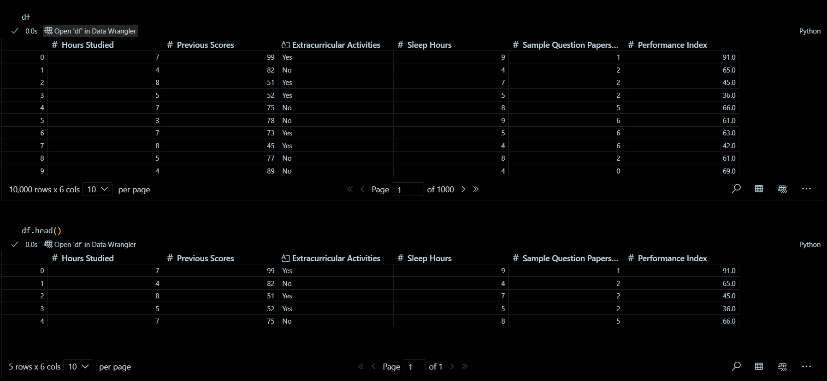

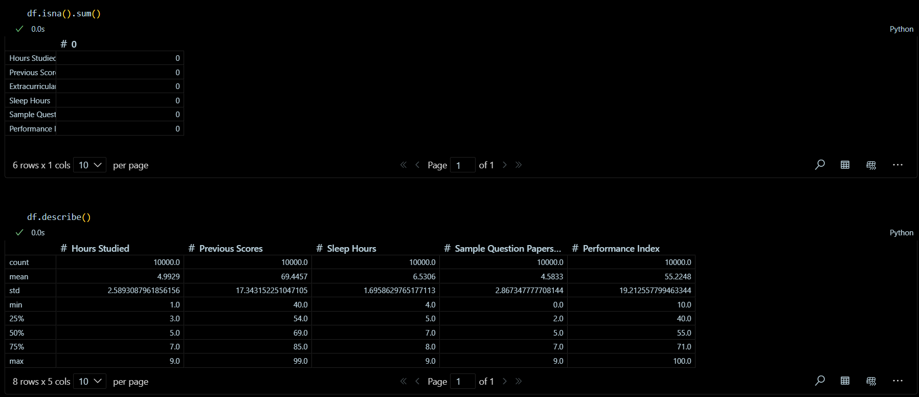

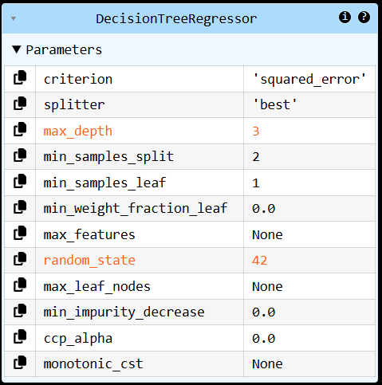



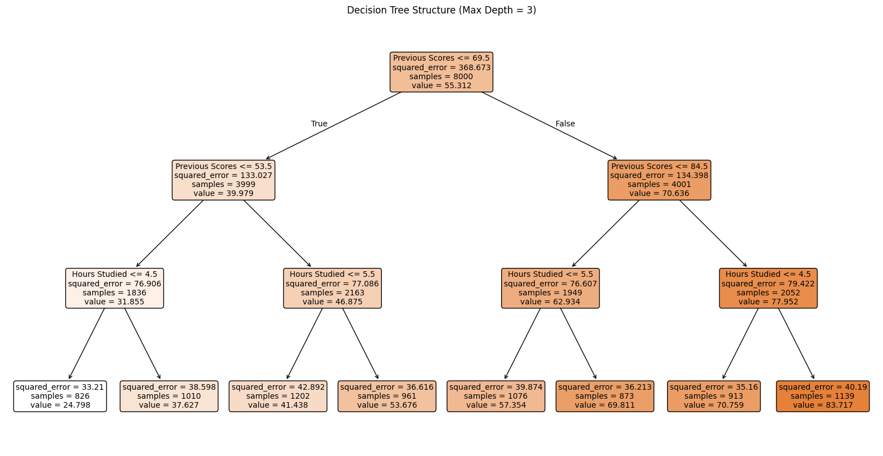

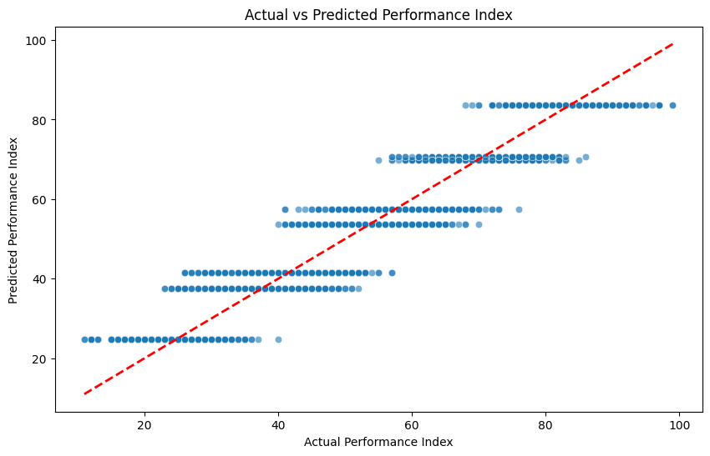

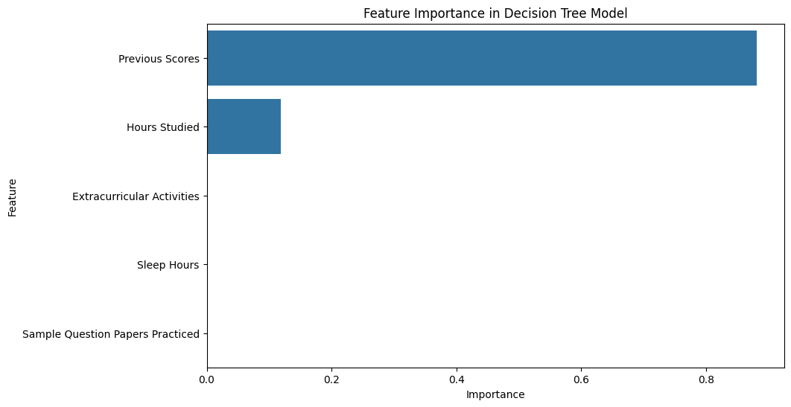

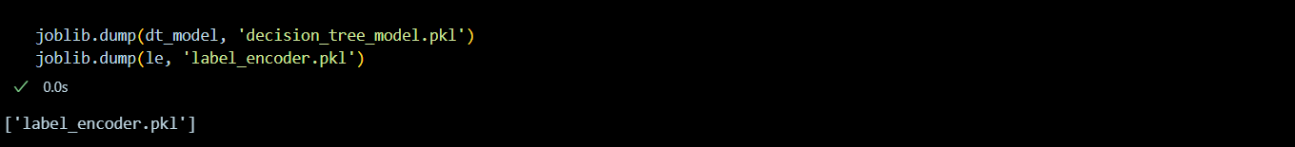



**Output**

Unique values in 'Extracurricular Activities' before encoding: ['Yes' 'No']

Encoded values for 'Extracurricular Activities': [1 0]

LabelEncoder classes: ['No' 'Yes']

Mean Squared Error: 8.82

R^2 Score: 0.98

Decision tree visualization saved as 'decision_tree_structure.png'

Actual vs Predicted scatter plot saved as 'actual_vs_predicted.png'

Feature importance plot saved as 'feature_importance.png'

Loaded LabelEncoder classes: ['No' 'Yes']

Predicted Performance Index: 75.50